POLO SABLET

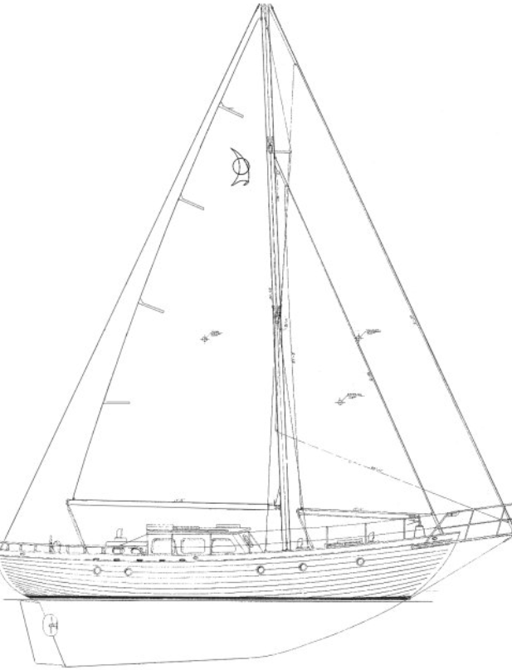

Builder: Sino-American Yacht Builders.
Designer: Ron Amy

Hull Type - Long Keel
Rigging Type - Cutter
LOA - 11.88 mtrs
LWL – 9.32 mtrs
Beam – 3.44 mtrs
Displacement – 10,659 kgs
Ballast – 3,992 kgs
Ballast Type – Iron
Construction - GRP
Max Draft – 2.1 mtrs
Year – 1980
Berths - 6

Status :
Duty is paid / no VAT applicable / purchased by the present owner in September 1997
Price: Euro 100,000.- for immediate handover.

Auto pilot
Fish and depth finder
GPS
Fixed and portable VHF
Bow prop
Extinguishers
Avon life raft
Life jackets
Life Buoys
Hydraulic steer
Emergency manual tiller
Engine Perkins SABRE M65 Max boat speed 8 knots 4 cylinder yom 2004
New main sail
Genoa
Spare main
Medium genoa
Storm gen
Swimming ladder
Solid teak bow sprit
Electric Windlass
Anchor meter
1 spare anchor
Fridge
Icebox
Cooker Hob
Oven
Water heater
Air conditioning
Stereo and DVD Player
TV
Others
Cutlery
Crockery
Glasses

Maintenance :
All electrics, pumps, and pipework are serviced annually
Boat yearly on the hard for 5 months at Kalkara boat yard, covered with thermoplasty, where she is maintained annually to high standards
Varnished annually with 10 coats of varnish
Boat fully sprayed 4 years ago at Kalkara Boat Yard
All sea socks are serviced annually at the yard
Serviced rig and vanes yearly
Every 5 years, the engine is taken out of the boat and works carried out.
Engine service 3 times yearly
Deck fully serviced 2025

